Cost-effective and user-friendly Vehicle Tracking System using GPS and GSM Technology based on IOT

A Thesis Report Submitted By

Mahmudul Hasan Mehedy

ID#14103113

In Partial Fulfillment of the Requirements for the Award of

Bachelor of Computer Science and Engineering



Department of Computer Science and Engineering

College of Engineering and Technology

IUBAT-International University of Business Agriculture and Technology

Summer 2021 – spring 2022

Cost-effective and user-friendly Vehicle Tracking System using GPS and GSM Technology based on IOT

Mahmudul Hasan Mehedy

A thesis report submitted in partial fulfillment of the requirements for the degree of

Bachelor of Computer Science and Engineering (BCSE)

The thesis has been examined and approved,

______________________________

Dr. Utpal Kanti Das

Chair and Professor

Dept. of Computer Science and Engineering

IUBAT – International University of Business Agriculture and Technology

______________________________

Dr Hasibur Rashid Chayon

Coordinator and Associate Professor

Dept. of Computer Science and Engineering

IUBAT – International University of Business Agriculture and Technology

_____________________________

Sadika Islam Sneha

LecturerDept. of Computer Science and Engineering

IUBAT – International University of Business Agriculture and Technology

Department of Computer Science and Engineering

College of Engineering and Technology

IUBAT – International University of Business Agriculture and Technology

Summer 2021 – spring 2022

# **Abstract**

Security is very apart important for vehicles to prevent the injury as vehicle theft is very common phenomenon now a days. We can ensure the security of our vehicles via monitoring our vehicles 24/7. There are many possible ways to track a vehicle. A few groups do not concern about the users need. My research is about the tracking vehicle according to user’s demand. I am concerning on low budget, better geographic coordinate and easy user access. The system needs GPS and GSM technology. User can access the system by Short Message Service (SMS) on a mobile phone. GSM module communicate with the user and GPS module communicate with satellite to get latitude and longitude coordinate. Location of Vehicle's on Earth is determined using Google Maps.

# **Letter of Transmittal**

18th May, 2022

Chairman

College of Engineering and Technology (CEAT)

IUBAT- International University of Business Agriculture and Technology

4 Embankment Drive Road, Sector-10, Uttara Model Town

Dhaka-1230, Bangladesh.

**Subject: Submission of report**

Dear Sir,

With due respect, this is our pleasure to present our report entitled “Cost-effective and user-friendly Vehicle Tracking System using GPS and GSM Technology based on IOT”. I prepared this report as partial fulfillment of the thesis. I have tried my level best to prepare this thesis report to the requirement standard. It was certainly a great opportunity for me to work on this paper. Now, I am looking forward for your kind appraisal regarding this thesis paper.

I shall remain deeply grateful to you if you kindly go through this report and evaluate my performance. I hope that you would find the report competent augmented.

Yours sincerely,

**____________________**

Mahmudul Hasan Mehedy

ID#14103113

# **Student’s Declaration**

I am hereby declared that this paper titled **“Cost-effective and user-friendly Vehicle Tracking System using GPS and GSM Technology based on IOT”** is my original work and has not been presented elsewhere for assessment or award of any other degree or any other publication. Any additional resources have been properly acknowledged and referred.

Mahmudul Hasan Mehedy

ID#14103113

# **Acknowledgements**

This report would not have been possible without the essential and gracious support of many individuals who encouraged me to complete this paper on time. I want to express my gratitude & respect to my honorable Coordinator Dr Hasibur Rashid Chayon, IUBAT- International University of Business Agriculture and Technology for his constant, guidance, encouragement & every possible help in the overall preparation of this thesis paper. I shall remain thankful for the advice and suggestions provided by Supervisor Sadika Islam Sneha, Lecturer, IUBAT.

Finally, I would like to give special thanks to my parents for their support to continue the course.

# **Supervisor’s Certification**

I certify that the student Mahmudul Hasan Mehedy (ID#14103113) carried out his thesis work **“Cost-effective and user-friendly Vehicle Tracking System using GPS and GSM Technology based on IOT”** atInternational University of Business Agriculture and Technology (IUBAT) between June 14,2021 and May 18,2022. During this period, he consulted me on regular basis as required by the department. I therefore recommended that his thesis report be accepted for final presentation.

____________________

Sadika Islam Sneha

Lecturer  
Department of Computer Science & Engineering

IUBAT-International University of Business Agriculture and Technology

# **Table of Contents**

Abstract iii

Letter of Transmittal iv

Student’s Declaration v

Acknowledgements vi

Supervisor’s Certification vii

Table of Contents viii

List of Figures ix

List of Tables x

Chapter I. Introduction 1

1.1 Background 2

1.2 Problem Statement 4

1.3 Significance of the Problem 4

1.4 Objectives 4

1.5 Research Question 5

1.6 Research Hypothesis 5

Chapter II. Literature Review 6

2.1 Review of Related Literature 7

Chapter III. Methodology 10

3.1 Existing System 11

3.2 Proposed System 11

3.3 Block Diagram of the System 12

3.4 Hardware Requirement 13

3.4.1 Arduino Uno Board Descriptions 13

3.4.2 SIM808-GSM/GPS/GPRS Shield with Antenna 14

3.5 SOFTWARE REQUIREMENT 15

3.5.1 Arduino IDE 15

3.6 Proposed System Design 16

3.6.1 Flowchart 17

Chapter VI. Result & Discussion 18

4.1 Implementation 19

4.1.1 Hardware Implementation 19

4.1.2 System Cost 20

4.2 RESULT AND DISCUSSION 20

Chapter V. Conclusion 23

5.1 Conclusion 24

5.2 Limitations 25

5.3 Future Work 25

References 26

# **List of Figures**

Figure 3. 1 Conceptual Design 11

Figure 3. 2 Block diagram 13

Figure 3. 3 Arduino Uno 14

Figure 3. 4 SIM808-GSM/GPS/GPRS Shield with Antenna 15

Figure 3. 5 Interface of Arduino IDE 16

Figure 3. 6 Flowchart of the system 17

Figure 4. 1 Implementation Design of the System 19

Figure 4. 2 (a)Text message with Google Map link to show (b) location at Google Map 21

# **List of Tables**

Table 4. 1 The cost estimation table of the System 20

Table 4. 2 The performance of the System 1st case 21

Table 4. 3 The performance of the System 2nd case 22

# **Chapter I. Introduction**

## **1.1 Background**

Vehicle Tracking is the method of remotely determining location of vehicle. Technology does have an impact on how we think and live. It is now possible to follow a vehicle. Nowadays, there are numerous options for tracking a vehicle.

They are classified in two categories:

1. Passive-when a GPS unit collects data from the tracker that needs to be downloaded.
2. Active- "Active" trackers are GPS trackers that work in real time.

The Government and military of the United States built Global Positioning System (GPS), which was supposed to be used for surveillance. The GPS was created as a result of a collaboration between the US Dr. Ivan and the Department of Defense Developing a satellite-based course planning system that is mostly used for navigation. GPS project entailed the development as well as launch of 18 satellites. Each orbital planes, there are six spaced 120 degrees apart, and their positions on the ground, cost around $12 billion at the time. These satellites are used for a variety of purposes reference points on a map using GPS to obtain and display precise geographic coordinates. The idea for a global positioning system was conceived during the Cold War to be used by military and intelligence organizations, and was inspired by Sputnik, a Soviet-launched spacecraft. Since its launch in 1960s, GPS has grown into a larger and more sophisticated satellite network constellation that orbits Earth at fixed places in space, broadcasting signals to anybody with a GPS receiver. The signals include a time code and a geographic data point, allowing us to show a device's exact location anywhere on the globe. Ground-based radio navigation systems like LORAN and the Decca Navigator, which were developed in the early 1940s and used throughout World War II, are based on the same concepts as GPS. In 1957, the Soviet Union launched the first Sputnik satellite, which delivered additional inspiration for GPS system. Sputnik's radio transmissions were being monitored by a team of US scientists led by Dr. Richard B. Kershner. They noticed that frequency of Sputnik signal increased as satellite reached them and reduced as it traveled away owing to the Doppler Effect. They realized that because they knew their exact location on earth, they could establish where the satellite was along its orbit by analyzing the Doppler distortion. In 1960, a successful test of the first satellite navigation system took place. It produces a five-satellite constellation that provides a navigational fix once every hour. US Navy launched the timation satellite in 1967, which is employed by the GPS system, demonstrated the capacity to set exact clocks in space. The ground-based Omega Navigation System, which was based on signal phase comparison, became the first global radio navigation system in the 1970s. During the early stages of the tracking, only two radio used to relay information. The car had one radio and the base station had another, allowing drivers to communicate with their bosses. Throughout their journeys, the fleet operator could keep track of their progress. Early technology has its own set of constraints. In terms of accuracy and more engagement between drivers and fleet operators, the distance constituted a stumbling barrier. The driver provided information to the base station, and a big fleet could not have been run only by humans. The landscape of vehicle tracking changed with the arrival of GPS technology. As a result, the use of manpower has been reduced. Computers were used to track the majority of labor. When it comes to managing a large fleet of vehicles, computers came in helpful. The information was also given more credibility as a result of this.

## **1.2 Problem Statement**

At any emergency situation of vehicle theft, it may not be able to identify the location of the vehicle, and cannot immediately defend the theft and protect the vehicle. The proposed system can be useful for vehicle for security purpose. It consists of a safety device having GPS and GSM which when activated and get a location request, it sends an message with location information to the requestor.

## **1.3 Significance of the Problem**

Theft of vehicles is a major concern. Vehicle theft is a crime, but it is linked to more serious crimes such as drug trafficking, arms smuggling, people smuggling, and international terrorism. From 2006 to the previous year, the rate of private car theft in our country was 0.8 per 100,000 people. If we can spread the use of tracking systems, we will be able to reduce this type of crime. Vehicle tracking systems are also advantageous in fleet management and driver monitoring.

## **1.4 Objectives**

To increase the safety of vehicle and reduce vehicle related crime. The main objectives follow:

1. To identify the location of the vehicle.
2. To discover the possible location with the GPS receiver.
3. To send location message via GSM with google map link to its requestor.
4. To get better GPS for exact location.
5. To made the system low budget.
6. To made the system user friendly.

## **1.5 Research Question**

The research question of the paper was as follows:

**Q1.** How to prevent the vehicle theft and increase the vehicle safety by IOT based device?

## **1.6 Research Hypothesis**

Prevention & locate is the aim of vehicle tracking system. The basic principle used for tracking system is prevention & locate by using GPS, GSM technology. The prevention of Vehicle theft, Molestation, kidnapping, drug trafficking, arms smuggling is most important events that can be prevent by event wireless communication. The SMS information can be sent to vehicle owner or other requestor to prevent those crime.

# **Chapter II. Literature Review**

## **2.1 Review of Related Literature**

Create a global positioning system (GPS) -based tracking device to detect the precise location of a vehicle to which it is attached and transmits that information to a user over a GSM modem (Gastgar et al.) but they have not shown in which format user receive the data and they use SIM900D as GSM module and a separate GPS module which cost is much higher and complex to maintain. It is planned to use a real-time Google Map and an Arduino-based vehicle tracking system, although the user only receives latitude and longitude information and they use a GPS and GPRS shield which have no antenna thus it make a problem to placement and to get real location (Rahman et al., 2016). The vehicle tracking device is installed within the vehicle and offers accurate real-time location information. The information can also be saved and downloaded to a computer for future research. Like (Anu et al., 2015) the system relies on RFID (radio-frequency identification), it can only detect buses in a specific area. A bus transceiver was incorporated in the system, which provided pupils with information on the whereabouts of a bus on a predetermined route, but no map was utilized to determine a real-world location (Lau, 2013). Use of a Radio Frequency Identification Technique Requirements They are only demonstrating how RFID may be used to track a system; no implementation has been provided (Möller et al., 2015). Vehicle tracking and location systems based on the Global System for Mobile Communication (GSM) and the Global Positioning System (GPS) added value by providing accurate, real-time vehicle location, mapping, and reporting data, as well as boosting the level of service given. The GPS-based vehicle tracking system is designed to determine any vehicle's exact location and send an SMS alert to the necessary authorities. Early technology had significant limitations as well. In terms of accuracy and more engagement between drivers and fleet operators, the distance constituted a stumbling barrier. The driver provided information to the base station, and a big fleet could not have been run only by humans. The landscape of vehicle tracking changed with the arrival of GPS technology. As a result, the use of manpower has been reduced. This concept will continuously track the location of a moving vehicle and provide on-demand updates on its status (Alexe and Ezhilarasie, 2011). The majority of labor was tracked using computers. Computers came extremely handy when it came to handling a huge fleet of automobiles. As a result of this, the information gained more credence. Automobiles are required for the transportation of commodities from one place to another. Delays in the delivery of items can cause a slew of issues for customers. Drivers may have chosen erroneous or longer routes when delivering, causing the delay. The Global Positioning System (GPS) is increasingly being used for fleet management, stolen vehicle recovery, mapping, and surveillance to address these concerns, (Alshamsi et al., 2016) Adafruit FONA 808 GSM + GPS Shield use by this system which cost is above BDT 3000 and also it provide GPS and GSM with very short antenna. Real-time vehicle tracking system of GPS and GSM technology based on ARM7 is presented., and it uses the SIM 900 A chip, which is substantially more expensive because GPS must be purchased separately (Mistary and Chile, 2015). System (San Hlaing et al., 2019) use ATE command to Arduino Uno to track the location of your vehicle, the Global Positioning System (GPS) and the Global System for Mobile Communication (GSM) technologies with short antenna. And we are concerned with a minimal budget, improved geographic coordinates, and user accessibility. Paper (Zhian and Han, 2010) describes a bus management system that executes the fundamental duties of an intelligent public transportation management system in a fixed route using ZigBee and GSM/GPRS. Also, scholar bus monitoring system with a set route was created (Zambada et al., 2015). New examples of applications arose as wireless communication technology advanced, such as the use of public network text messages to communicate mobile location information, referred to as the first generation of GPS dynamic positioning technology (LIAN and WENG, 2007). Paper (Morallo, 2021) implemented a tracking system using GPS module (NEO-6m), SIM900 GSM module which have higher price as separately we have to buy GPS and GSM module. GPS module (NEO-6m) provide a very short antenna thus it makes a problem for the system to capture GPS location. Also, user get only latitude and longitude value. RFID based tracking system developed in a fixed route (Deng, 2013). System (Lee et al., 2014) use GSM/GPRS module with SM5100B which provide a tiny antenna that can make problem to setup and get the accurate signal. System (Maurya et al., 2012) use separate GPS and GSM module that cost is higher and data received by the user is not shown in this paper. An ideal theoretical idea was developed to track vehicle (Parvez et al., 2010). (Bajaj and Gupta, 2012) Two type o tracking system (RFID and GPS) used in one system but exactly which module is used not clear. Demonstrate of low cost vehicle tracking and its need but no implementation (Jain and Goel, 2012). A hypothesis of low cost tracking system was published for user desire location for vehicle (Minni and Gupta, 2013). (Jethwa et al., 2015),(Mangla et al., 2017) This paper doesn't make clear about the GPS and GSM exact version and user get only latitude and longitude. (Bojan et al., 2014),(Sakib and Abdullah) Use separate GPS, GSM and we are concerning combine. U-Blox NEO-7M GPS and SIM900A GSM based tracking system is expensive one (Nadella et al., 2020).

# **Chapter III. Methodology**

## **3.1 Existing System**

Many of existing system use GPS, GSM technology and a microcontroller. Where user will send a request to GSM module via SMS and system will provide the coordinate value latitude and longitude which is helpful to find the location of the vehicle.

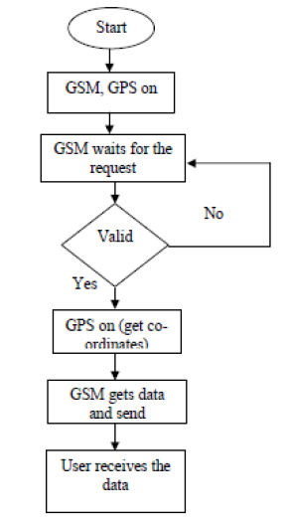

Figure 3. 1 Conceptual Design

## **3.2 Proposed System**

The main aim of this project is to protect the vehicle from theft and collect the location of the vehicle. For this purpose, I wanted to create a vehicle tracking system that can controlled with smartphone or embedded device. My target was to create low-cost, high-performance vehicle tracking system and implement it. And also, to provide a user-friendly and safe system for controlling vehicle theft, with a focus on assisting individuals of all ages. I use GPS, GSM technology and Arduino Uno as microcontroller. Where the user may send a SMS request to GSM module, and system will respond with coordinate value latitude and longitude as well as a link of Google Maps, which is useful for finding the actual real-time location of vehicle and makes system more user-friendly. I am using SIM808-GSM/GPS/GPRS Shield with Antenna which come with combine GPS and GSM module with a sufficient price. GPS Antenna consumes roughly 10 milliamps and gives an extra 28 dB gain. Also, it has a 5-meter cord, allowing quickly reach where the sky view is better (as better sky view gives better coordinates) likely headlight of car, near to front and back glass wherever it is needed according to the vehicles structure. Because the antenna is magnetic, it can be attached to a vehicle's roof, truck, or other steel structure. It operates at frequency of 1575.421.023 MHz, with 2.5V to 5.5V voltage range and a current range of 6.6 mA to 16.6 mA. As a result, it is possible to measure location more accurately than others.

## **3.3 Block Diagram of the System**

The design is embedded application, which continuously monitors moving vehicle and provides status reports on user demand. Arduino is serially connected with SIM808 GSM modem and GPS receiver in this system. Vehicle's latitude and longitude are sent from any remote location using GSM modem. Data is transmitted by the GPS modem, which comprises the vehicle's latitude and longitude. Hardware interfaces to microcontroller are SIM808's GSM modem and GPS receiver. DFRobot Library is used to interface the controller with the GSM modem and GPS receiver. When user sends request to GSM modem's number, system sends back message to that mobile, revealing the vehicle's latitude and longitude. On Google Maps, a program was designed to discover the actual location of the vehicle as well as the true traveled track of the moving vehicle.

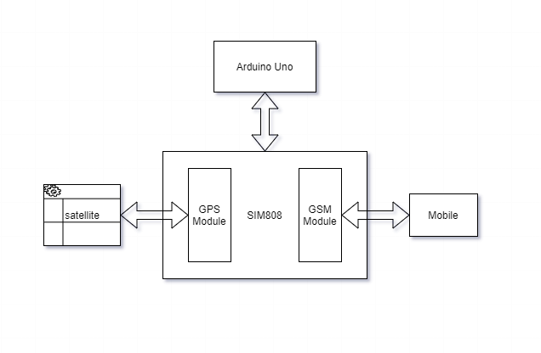

Figure 3. 2 Block diagram

## **3.4 Hardware Requirement**

Below given are the components that are needed for building this device: -

### **3.4.1 Arduino Uno Board Descriptions**

We will learn about the different components on the Arduino board. We will study the Arduino UNO board because it is the most popular board in the Arduino board family. In addition, it is the best board to get started with electronics and coding.

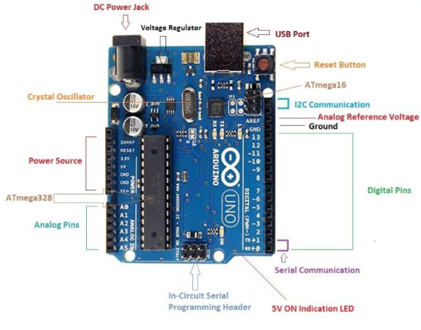

Figure 3. 3 Arduino Uno

### **3.4.2 SIM808-GSM/GPS/GPRS Shield with Antenna**

It works with the Raspberry Pi and Arduino microcontrollers. GPS Antenna (one), GSM Antenna (one), SIM808 Board (one) is included in the package.

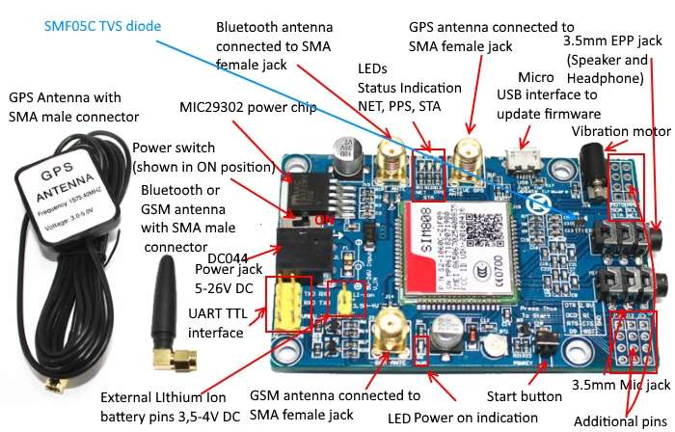

Figure 3. 4 SIM808-GSM/GPS/GPRS Shield with Antenna

## **3.5 SOFTWARE REQUIREMENT**

### **3.5.1 Arduino IDE**

The Arduino **Integrated Development Environment** (IDE) is a cross-platform application (for Windows, macOS, Linux) that is written in the programming language Java. It is used to write and upload programs to Arduino compatible boards, but also, with the help of third -party cores, other vendor development boards. The Arduino IDE supports the languages C and C++ using special rules of code structuring.

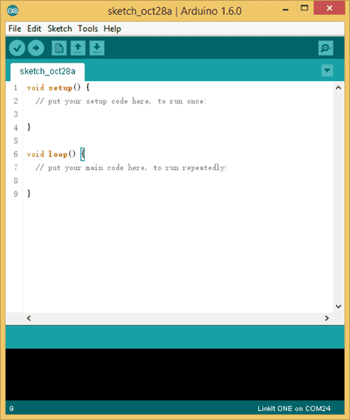

Figure 3. 5 Interface of Arduino IDE

## **3.6 Proposed System Design**

The Arduino UNO is employed as the main control mechanism in this system. After user send initialize message to GSM module in this system, Arduino locates the message, and the software serial prints the vehicle position latitude and longitude. At the time, the user received a message with the vehicle's latitude and longitude as well as a Google map link. GSM has no effect if the GPS module does not receive the signal. As a result, users must wait for a signal from a GPS satellite.

### **3.6.1 Flowchart**

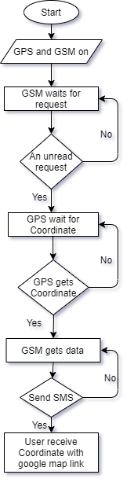

Figure 3. 6 Flowchart of the system

# **Chapter VI. Result & Discussion**

## **4.1 Implementation**

Include the DFRobot library programming for the SIM808, and define software serial communication. To facilitate serial communication on pins 10 TX and 11 RX, SoftwareSerial library is used. GND pin shared by common Arduino GND pins. When system is ready serial monitor will show Open the GPS power success and Init Success, please send SMS message to me! Otherwise, serial monitor will show Open the GPS power failure. After serial monitor showing Open the GPS power success and Init Success, please send SMS message to me! if GSM get an unread request or message, system will start to get GPS latitude and longitude. Soon after finding GPS location a return SMS will send to user. If system doesn't get GPS location it will send nothing to user, so users need to wait until system get the GPS location.

### **4.1.1 Hardware Implementation**

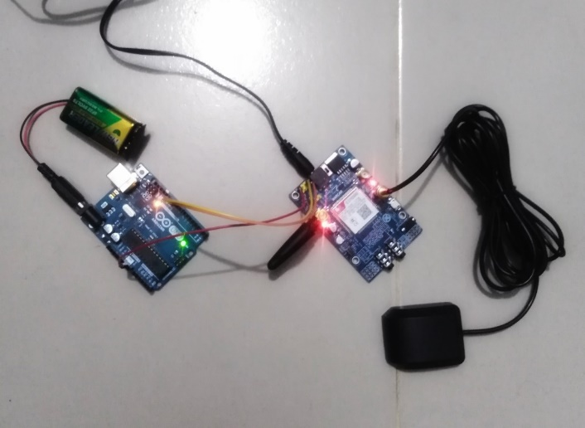

Figure 4. 1 Implementation Design of the System

### **4.1.2 System Cost**

As we are producing good results without costing a lot of money the cost estimation is as follows:

Table 4. 1 The cost estimation table of the System

|  |  |  |
| --- | --- | --- |
| # | Component | Price (BDT) |
| 1 | ARDUINO UNO R3 | 609 |
| 2 | 9V Battery to 2.1mm for Arduino Uno Connector | 20 |
| 3  4  5  6 | Battery 9V  SIM808 GSM/GPS/GPRS Shield with Antenna  Jumper Wires (M to F) 20 Pieces  5V 2A Power Adapter (Original) | 49  1990  32  194 |

Total Cost-BDT 2894

## **4.2 RESULT AND DISCUSSION**

The GSM module was used in this research to transmit and receive messages from another GSM number. If the vehicle owner wishes to know where their vehicle is, they must first send a message. The GSM module was functional at the time, sending SMS to the owner's cell phone number. The GPS module is also used in this thesis, so the message includes latitude and longitude of vehicle's location. If owner wants to see their vehicle's location on a Google map, they can do so. As a result, the user is always aware of their vehicle's whereabouts. I have introduced a feature that send SMS to the user based on the user's request for vehicle's location monitoring. The vehicle's latitude and longitude are included in the SMS. The SMS also contains a link to Google Maps, with this user can utilize to view the location.

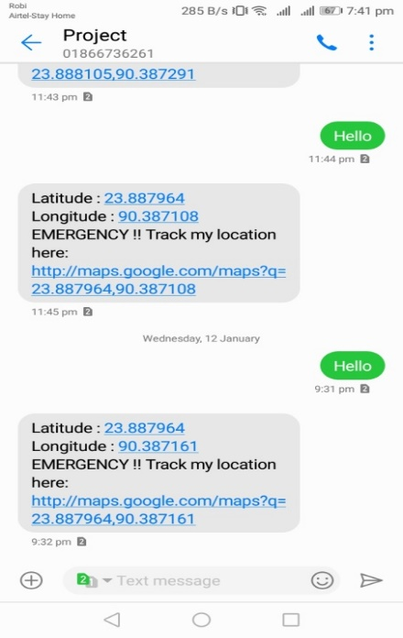 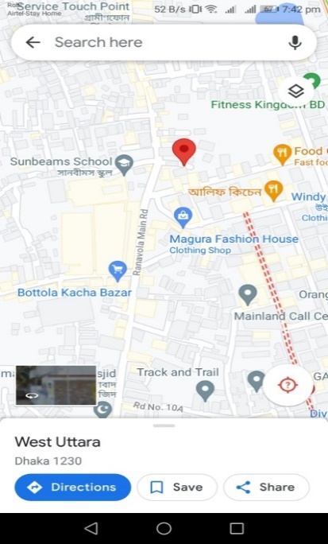

(a) (b)

Figure 8Figure 4. 2 (a)Text message with Google Map link to show (b) location at Google Map

The term "accuracy" refers to how closely a quantity's measured value corresponds to its "actual" value. The following table represents the accuracy of the system:

Table 4. 2 The performance of the System 1st case

|  |  |  |
| --- | --- | --- |
| # | Latitude | Longitude |
| 1 | 23.888449 | 90.387238 |
| 2 | 23.888338 | 90.387253 |
| 3  4  5 | 23.888262  23.888266  23.888273 | 90.387253  90.387207  90.387108 |

Table 4. 3 The performance of the System 2nd case

|  |  |  |
| --- | --- | --- |
| # | Latitude | Longitude |
| 1 | 23.887964 | 90.387161 |
| 2 | 23.887964 | 90.387108 |
| 3  4  5 | 23.887886  23.888037  23.887863 | 90.387321  90.387253  90.387108 |

# **Chapter V. Conclusion**

## **5.1 Conclusion**

The most crucial system for people nowadays is a tracking system; they want their car's security to be in good hands, and this is the major reason. As a result, vehicle tracking systems are becoming increasingly popular, not only in large cities but also in smaller towns. This technology is fully integrated, allowing user to easily track their vehicle position any time from any location. Vehicle theft is on the rise, but people have found a way to keep a watch on their automobiles without having to be in close proximity to them. These systems keep a tight grip on thefts and, to some extent, assist prevent them. We created vehicle tracking system and tested that can track exact position of moving and stopped vehicle in real time. This paper contains information about development and vehicle tracking system implementation. Smartphone and in-vehicle device make up the tracking system. The in-vehicle device in this study consisting of microcontrollers and SIM808 GPS/GSM/GPRS module that captures positions of vehicle data and transfers it through the GSM/GPRS network according the user's smartphone. The Google Maps application is utilized to view vehicle's geographic coordinates. A Google map link is sent to the user's smartphone, which displays Google Maps location of vehicles. In an experimental situation, the system is able to demonstrate ability to track vehicle's whereabouts at any time and from any location. Furthermore, due to the fact that our solution is based on commercially accessible electrical modules, it is low-cost. This procedure is dependable as well as safe. This setup is reasonably easy to modify, allowing to adapt to future needs without having to start over from the beginning, resulting in increased efficiency. In this study, the GSM module was utilized to transmit and receive SMS. 2G, 3G, and 4G networks may be supported using the GSM module. Our paper describes a tracking system at a minimal cost that uses the GSM network's GPS and GPRS for a diverse set of uses around the world. Use of GPS and GPRS together allows for tracking in real time and on a continuous basis. When compared to SMS-based tracking solutions, the cost is far lower. The usage of an HTTP link as a data transmitting technique improves the user-friendliness of the system. The full deployment of the suggested method is projected to better GPS location and lower the cost of SMS-based tracking systems in the long run.

## **5.2 Limitations**

* Signal can be jam in rural areas as SIM card is used.
* As battery is used for power supply, power failure can happen.
* SMS cost is higher as we need to send a request SMS every time to get the location.

## **5.3 Future Work**

* It is possible to reduce the SMS cost by using a software which can give request to the system to minimize SMS cost.
* Sometimes system user may need to monitor the previous location check which can be solved by adding a database to preserve data for later view.

# **References**

ALEXE, A. & EZHILARASIE, R. 2011. Cloud computing based vehicle tracking information systems. *IJCST,* 2**,** 49-52.

ALSHAMSI, H., KËPUSKA, V. & ALSHAMSI, H. 2016. Real time vehicle tracking using arduino mega. *International Journal of Science and Technology,* 5**,** 624.

ANU, V. M., SARIKHA, D., KEERTHY, G. S. & JABEZ, J. An RFID based system for bus location tracking and display. International Confernce on Innovation Information in Computing Technologies, 2015. IEEE, 1-6.

BAJAJ, D. & GUPTA, N. 2012. GPS based automatic vehicle tracking using RFID. *International Journal of Engineering and Innovative Technology (IJEIT),* 1**,** 31-35.

BOJAN, T. M., KUMAR, U. R. & BOJAN, V. M. Designing vehicle tracking system-an open source approach. 2014 IEEE International Conference on Vehicular Electronics and Safety, 2014. IEEE, 135-140.

DENG, J. 2013. Architecture Design of the Vehicle Tracking System

based on RFID. *Indonesian Journal of Electrical Engineering and Computer Science*.

GASTGAR, S. R., VATTI, R. A., DHOKE, S. B. & THORBOLE, S. D. Design of GPS and GSM based tracking system Design of GPS and GSM based tracking system.

JAIN, K. & GOEL, R. GPS based low cost intelligent vehicle tracking system (IVTS). International Conference on Traffic and Transportation Engineering (ICTTE 2012) IPCSIT, 2012. 93-97.

JETHWA, A. H., SHEFFER, E. & THOMPSON, M. 2015. Vehicle Tracking System Using Gps and Gsm Modem-a Review. *Int. J. Recent Sci. Res,* 6**,** 4805-4808.

LAU, E. C.-W. 2013. Simple bus tracking system. *Journal of Advanced Computer Science and Technology Research,* 3**,** 60-70.

LEE, S., TEWOLDE, G. & KWON, J. Design and implementation of vehicle tracking system using GPS/GSM/GPRS technology and smartphone application. 2014 IEEE world forum on internet of things (WF-IoT), 2014. IEEE, 353-358.

LIAN, X. & WENG, Y. 2007. Warehouse logistics control and management system based on electronic tag [J]. *Computer Engineering and Design,* 10**,** 056.

MANGLA, N., SIVANANDA, G. & KASHYAP, A. A GPS-GSM predicated vehicle tracking system, monitored in a mobile app based on Google Maps. 2017 International Conference on Energy, Communication, Data Analytics and Soft Computing (ICECDS), 2017. IEEE, 2916-2919.

MAURYA, K., SINGH, M. & JAIN, N. 2012. Real time vehicle tracking system using GSM and GPS technology-an anti-theft tracking system. *International Journal of Electronics and Computer Science Engineering,* 1**,** 1103-1107.

MINNI, R. & GUPTA, R. Low cost real time vehicle tracking system. 2013 Fourth International Conference on Computing, Communications and Networking Technologies (ICCCNT), 2013. IEEE, 1-5.

MISTARY, P. V. & CHILE, R. Real time Vehicle tracking system based on ARM7 GPS and GSM technology. 2015 Annual IEEE India Conference (INDICON), 2015. IEEE, 1-6.

MÖLLER, D. P., DERIYENKO, T. & VAKILZADIAN, H. Cyber-physical vehicle tracking system: Requirements for using a radio frequency identification technique. 2015 IEEE International Conference on Electro/Information Technology (EIT), 2015. IEEE, 552-557.

MORALLO, N. T. 2021. Vehicle tracker system design based on GSM and GPS interface using arduino as platform. *Indonesian Journal of Electrical Engineering and Computer Science,* 23.

NADELLA, H., NARAYANAN, G., GOUDA, P., KRISHNAN, S., GUPTA, A. & MARRIPELLY, A. LDR Based Power Consumption of Vehicle Tracking System. 2020 International Conference on Wireless Communications Signal Processing and Networking (WiSPNET), 2020. IEEE, 145-148.

PARVEZ, M. Z., AHMED, K. Z., MAHFUZ, Q. R. & RAHMAN, M. S. A theoretical model of GSM network based vehicle tracking system. International Conference on Electrical & Computer Engineering (ICECE 2010), 2010. IEEE, 594-597.

RAHMAN, M. M., MOU, J. R., TARA, K. & SARKAR, M. I. Real time Google map and Arduino based vehicle tracking system. 2016 2nd International Conference on Electrical, Computer & Telecommunication Engineering (ICECTE), 2016. IEEE, 1-4.

SAKIB, S. & ABDULLAH, M. S. B. GPS-GSM based Inland Vessel Tracking System for Automatic Emergency Detection and Position.

SAN HLAING, N. N., NAING, M. & SAN NAING, S. 2019. GPS and GSM based vehicle tracking system. *International Journal of Trend in Scientific Research and Development (IJTSRD)*.

ZAMBADA, J., QUINTERO, R., ISIJARA, R., GALEANA, R. & SANTILLAN, L. An IoT based scholar bus monitoring system. 2015 IEEE First International Smart Cities Conference (ISC2), 2015. IEEE, 1-6.

ZHIAN, L. & HAN, H. A bus management system based on ZigBee and GSM/GPRS. 2010 International Conference on Computer Application and System Modeling (ICCASM 2010), 2010. IEEE, V7-210-V7-213.